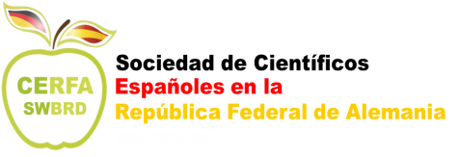

Acceptance Form: UAM/CERFA TRAINEESHIPS 2019

We hereby declare that, as possible Host Institution, we have read this application and we will accept a student from the Autónoma University of Madrid (UAM) as a trainee under ERASMUS + Programme for a practical training period of ………. months, starting on (day/month/year) ……………………… until (day/month/year).……………

We also declare that as receiving Organization/Entreprise, we will provide appropriate support and equipment to the trainee.

The student will be under the direct supervision of Mr/Mrs ………………........................................ (host applicant/scientific supervisor) who is included in the department/faculty .....................................................

Names, surname, signature and stamp when applied:

Host Institution

Principal Investigator of the host supervisor group (if different from the applicant)

Host Applicant / Scientific Supervisor

