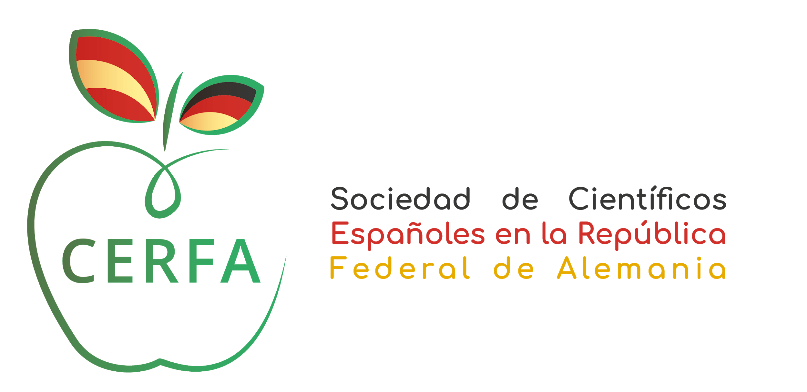

Acceptance Form: CERFA TRAINEESHIP PROGRAMME 2024

We hereby declare that, as a possible Host Institution, we have read this application and will accept a student as a trainee under the ERASMUS + Programme for a practical training period of ………. months (final dates are to be agreed upon with the student).

We also declare that as the receiving Institution/Enterprise, we will provide appropriate support and equipment to the trainee.

The student will be under the direct supervision of Mr/Mrs ………………........................................ (Host Applicant - Scientific supervisor) who is included in the department/faculty .....................................................

Name, Surname, Signature and Stamp when applied:
Host Institution:

Principal Investigator of the host supervisor group (if different from the applicant):
I confirm that I have read this application, agree to the student working in the applicant’s laboratory for the specified period and if applicable, I confirm that the group/department will cover the cost of the consumables related to this project.

Host Applicant / Scientific Supervisor:

